Experiment 1
- Open Umbrello UML Modeller.
- Create a new UML project.
- Select Class Diagram.
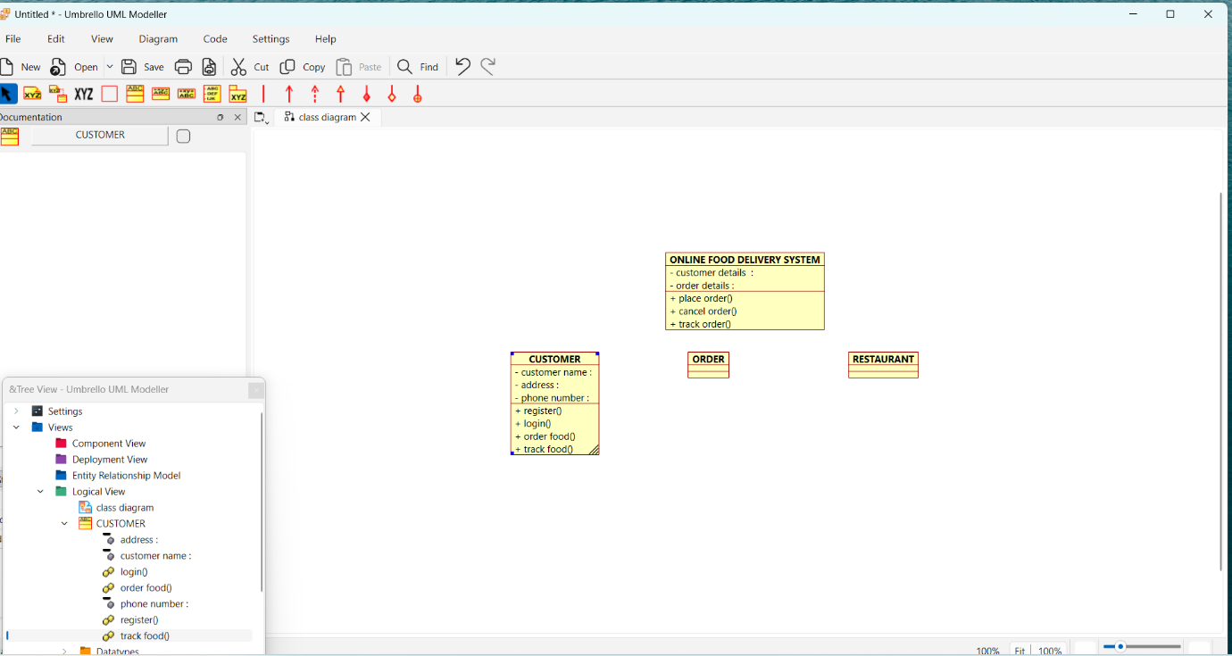
- Create the classes: Customer, Order, Restaurant.
- Add the required attributes and methods to each class.
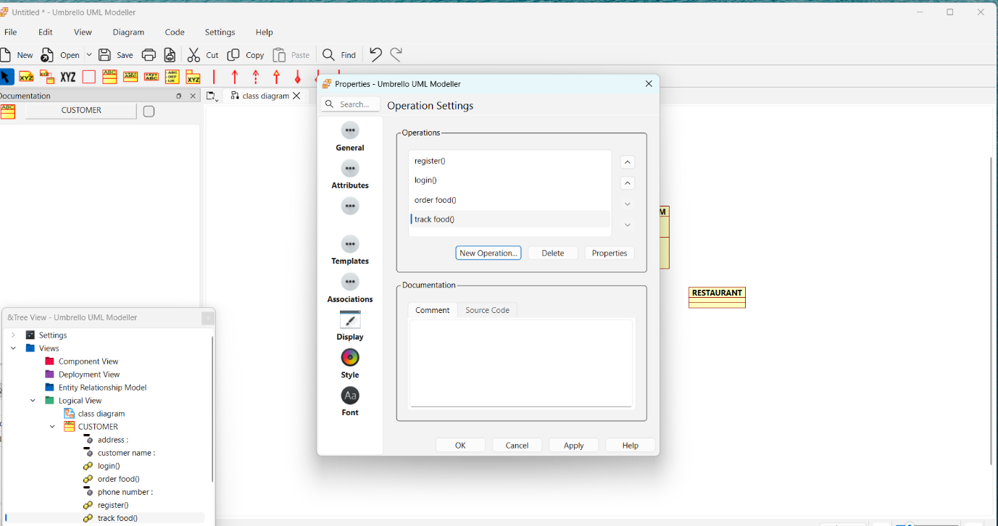
- Connect the classes using association relationships.
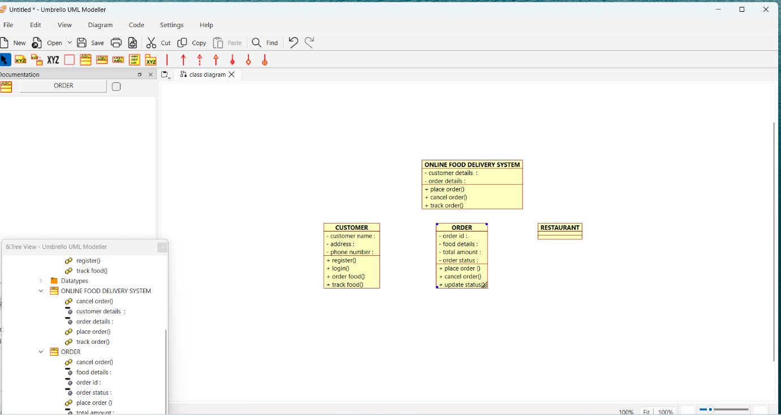
- Arrange the classes neatly.
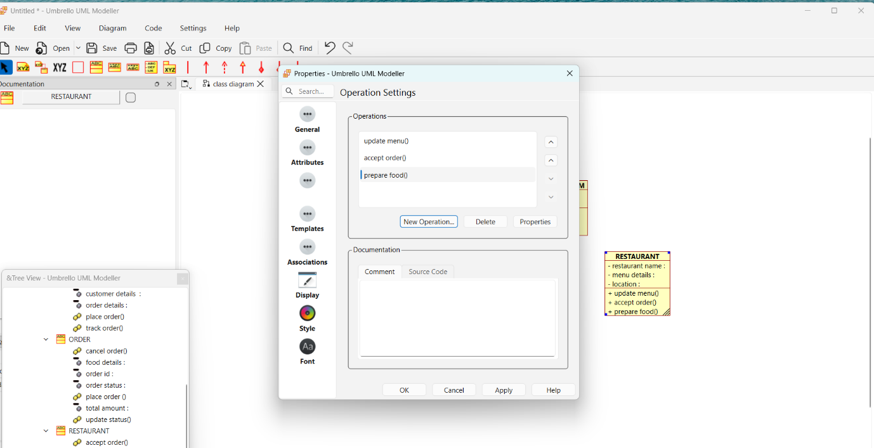
- Save the diagram.
- Verify that the diagram correctly represents the Online Food Delivery System.
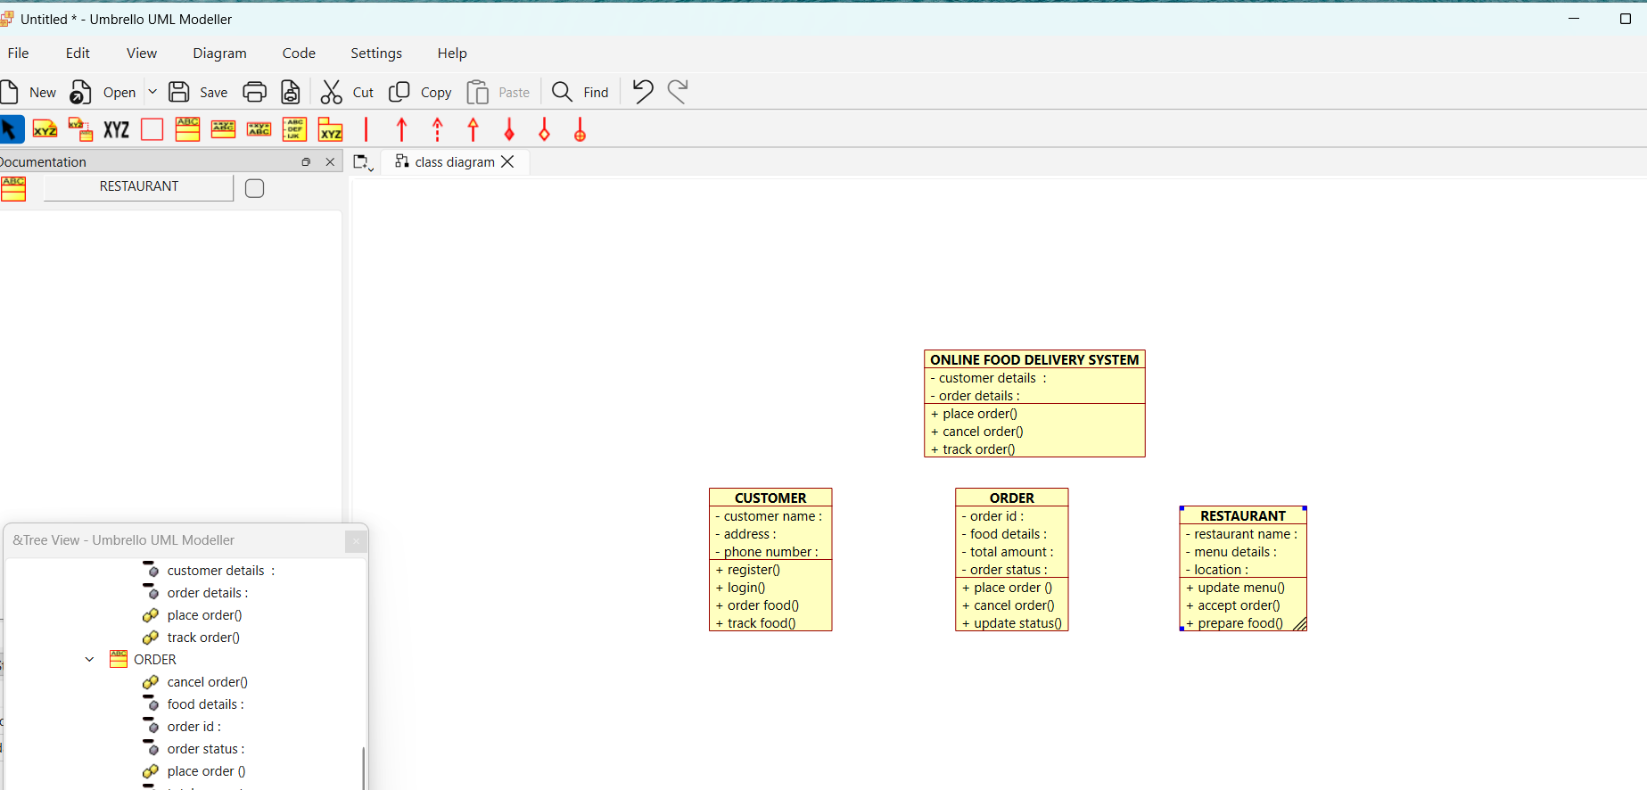
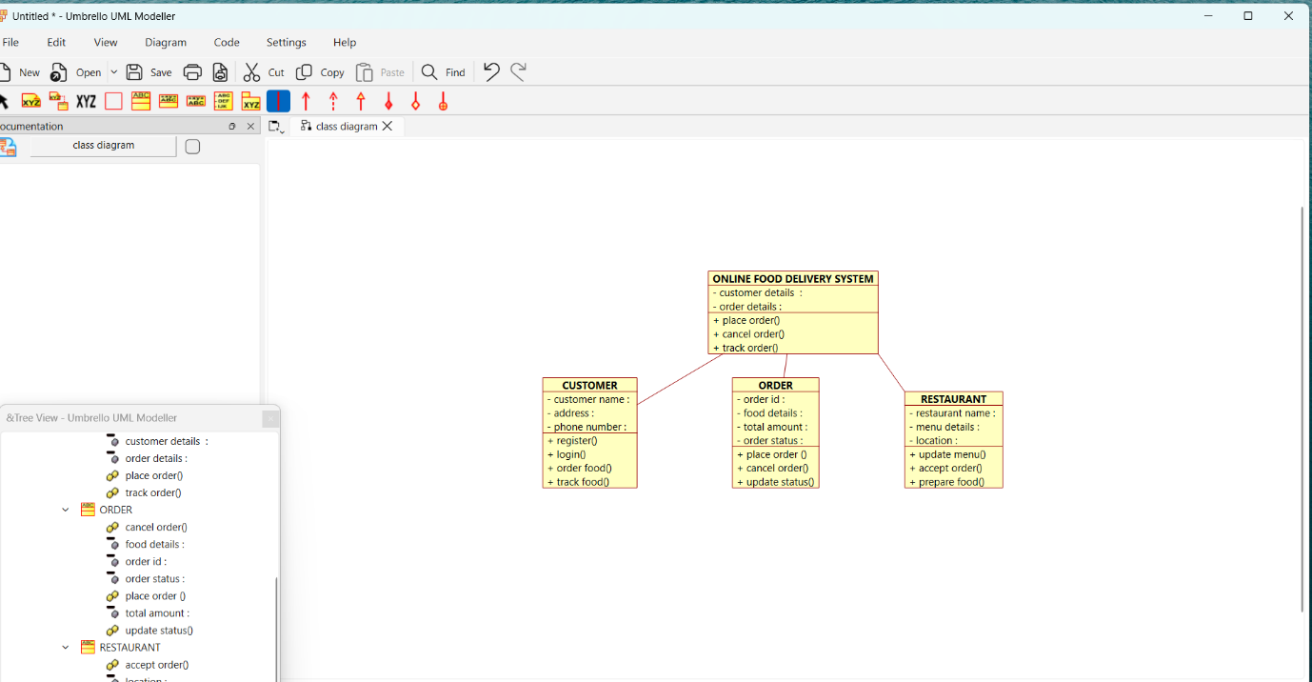
Use Case Diagram :

Procedure
- Open Umbrello UML Modeller.
- Create a new UML project.
- Select Use Case Diagram.
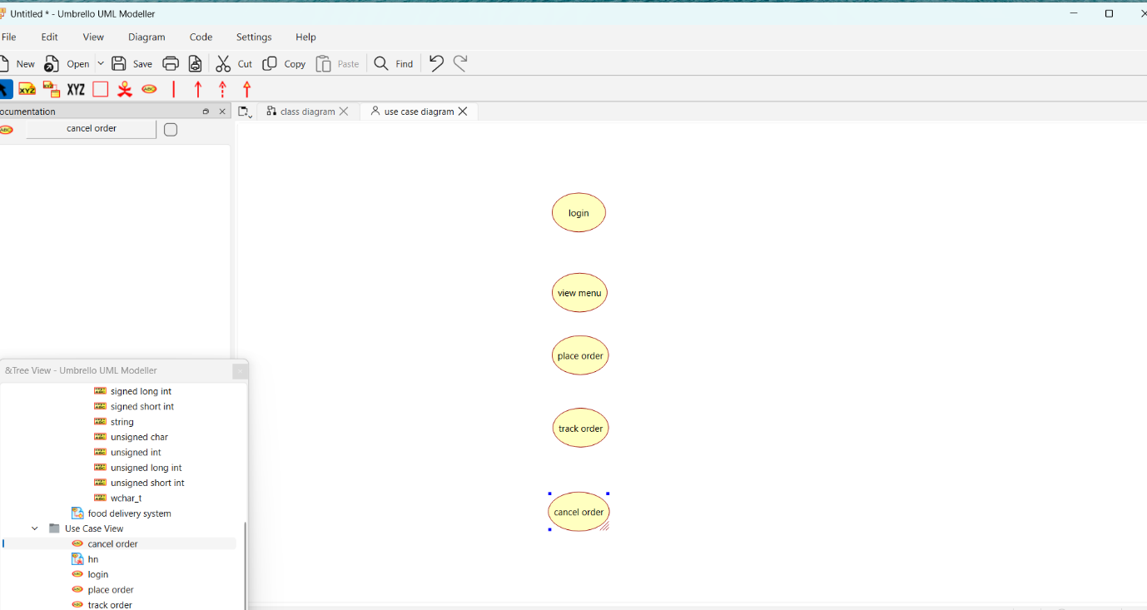
- Add the actors: Customer, Restaurant, and Delivery Agent.
- Create the use cases such as Register/Login, View Menu, Place Order, Make Payment, Track Order, Manage Menu, and Update Delivery Status.
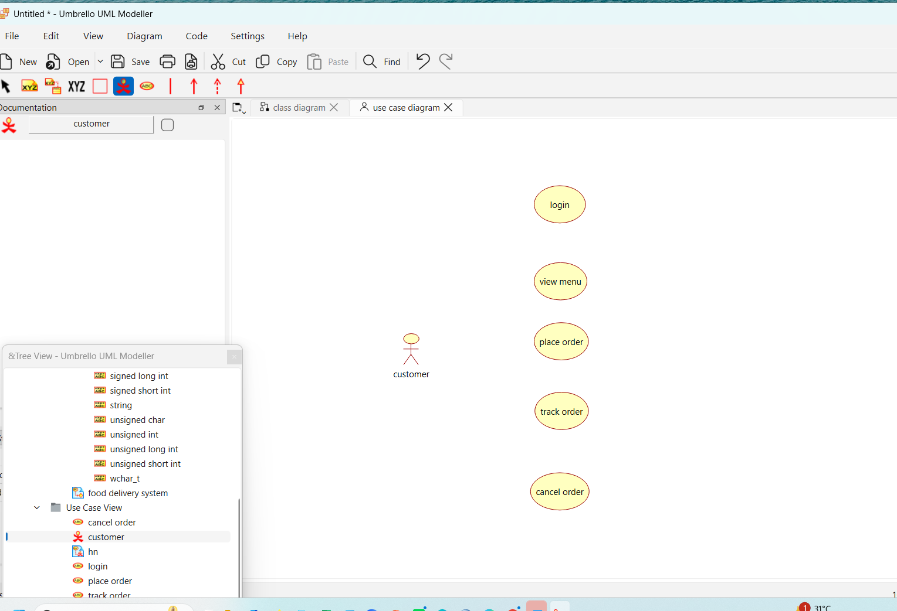
- Connect the actors to the appropriate use cases.
- Arrange the diagram neatly.
- Save the diagram.
- Verify that all user interactions are correctly represented.
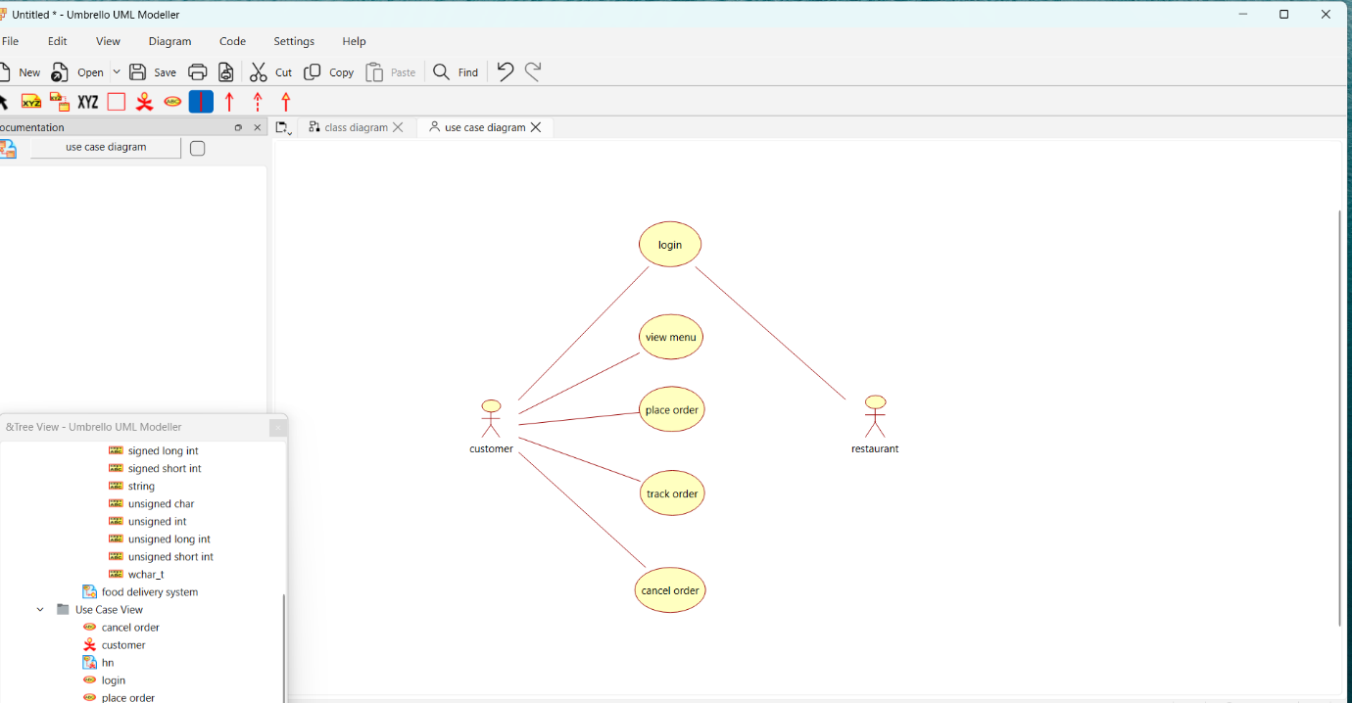

Activity Diagram :

Procedure
- Open Umbrello UML Modeller.
- Create a new UML project.
- Select Activity Diagram.
- Add the Start node.
- Create the activities: Register/Login, View Menu, Select Food, Place Order, Restaurant Receives Order, Prepare Food, Deliver Food, and Order Completed.
- Connect the activities using control flow arrows.
- Add the End node.
- Arrange the activities in the correct order.
- Save the diagram.
- Verify that the workflow correctly represents the Online Food Delivery System.

